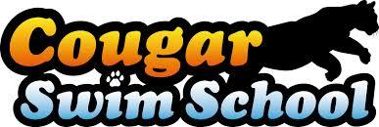 Release Of Liability

Name of Student: ______________________________________________________________Age: ________

Name of 2nd Student: ___________________________________________________________Age: ________

Name of Parent/Guardian ____________________________________________________________________

Address: __________________________________________________________________________________

Best Contact Phone: _________________________________ 2nd Phone: ______________________________

Class Level: _______________________________________ Session #: ________ Class Time: ___________

I, ________________________________________do hereby give my permission to allow my above-mentioned child to participate in aquatic activities offered by Cougar Swim School at the San Lorenzo Valley High School pool with the consent of the San Lorenzo Valley Unified School District. Cougar Swim School is neither approved, carried out, nor supervised by the District and Kurt Edwards; (Contractor) is solely responsible for the Cougar Swim School program. I acknowledge that even with careful supervision swimming, water polo, and diving are dangerous activities that may result in serious spinal injury, broken bones, and death. I agree to release, indemnify, hold harmless Kurt Edwards, his employees, agents, volunteers and waive all claims, liability, (Including attorney’s fee) for property damage, bodily injury and death arising from my/child’s negligence or willful misconduct relating to my or my child’s participation in the programs offered by Cougar Swim School.

Signed: ______________________________________Printed: _____________________________________

Date: ________________________________________Email:_______________________________________

Pool Location: San Lorenzo Valley High School Pool, 7501 Highway 9, Felton, CA 95005

Cougar Swim School: Ben Lomond, CA 95005. Phone: 831-239-4228, kurt@cougarswimschool.com

